-CALL FOR PROPOSALS-

“A” is for Amateur
An NHF and CHM Collab.
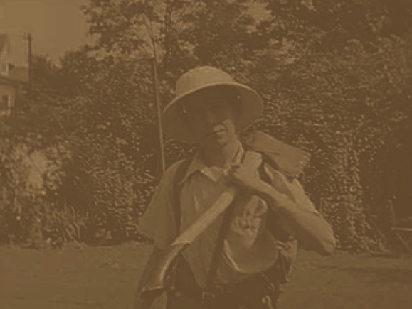
July 18-20, 2019

20th Annual Northeast Historic Film Summer Symposium

Bucksport, Maine, USA
Proposals Due: March 18, 2019

-Seeking presentation proposals from archivists, collectors and academics-

Come celebrate the 20th anniversary of the NHF Summer Symposium!

2019 marks 20 years for our little gathering. And we are celebrating by collaborating with our friends with the Center for Home Movies.

2019 is also the centennial of the birth of the late Robbins Barstow of Wethersfield, Connecticut. Robbins was an amateur filmmaker for seven decades and his "Disneyland Dream" was named to the National Film Registry. Robbins presented his 1936 film "Tarzan and the Rocky Gorge" at the 2005 Summer Symposium.

NHF is built on its commitment to amateur and small gauge film. And this year, we dig deep into our roots. Though we will be celebrating the work of, Robbins Barstow, an acknowledged Northeast amateur-auteur, our idea for this program is far from regionally specific. We want amateur movies, travel films, home movies, video, and small gauge work from anywhere and everywhere! And we want to hear your ideas about this material. Your own family films? Sure. Oddities hiding in plain sight in your collections? By all means! Our aim is to consider a variety of perspectives on a category of moving images that is delightfully difficult to pin down.

Twenty-first century regional moving image archives discover and collect increasingly diverse audiovisual artifacts that represent increasingly diverse media-making populations. We seek to bring together archivists, collectors, scholars, and practitioners involved with regional AV archives—and regional AV collections within a general archives—to consider this topic from a range of positions. THIS IS NOT MERELY A CONCEPTUAL, ACADEMICALLY-FOCUSED SYMPOSIUM TOPIC. The concept of “amateurism” also has a profound effect on, for example, structures of institutional funding and support as well as individual and collective priorities.

Calling upon the regional moving image archive community internationally, we hope to create an atmosphere for sharing case studies, developing collaborative initiatives, discussing what works and what doesn’t, and screening/discussing representative amateur moving images from the world’s regional film and AV archives.

Some topics to consider…others are welcome:

--The meanings of amateurism
--Amateur auteurs
--Collection/funding policies
--Itinerant film/filmmakers
--Film clubs
--Amateur film magazines
--Investigations (and demos!) of equipment
--Best practices and case studies
--Travelogues, tourist films, vacation films/videos

--Local/regional politics and programs
--Home movie days,
--Personal archiving efforts
--Home movies as primary resource
--Repatriation and changes of custodianship
--Repurposing of home movies
--Amateur social justice media (film, video, online)
--Protest footage
--Local Cable Access programming

Please send a 250-500 word abstract outlining your presentation idea and a brief cv via e-mail to: symposium@oldfilm.org.

The Summer Symposium Program Committee is: Devin Orgeron, Professor Emeritus, North Carolina State University; Liz Czach, University of Alberta; Dino Everett, University of Southern California; Mark Neumann, Northern Arizona University; Brian Real, Southern Connecticut State University; and Travis Wagner, University of South Carolina. We are happy to discuss your presentation ideas with you in advance of a formal submission. The Symposium Program Committee will begin reviewing proposals on March 18, 2019 and will finalize the program by April 17, 2019.

Northeast Historic Film, an independent nonprofit organization, was founded in 1986 to preserve and make available moving images of interest to the people of northern New England (Maine, New Hampshire, Vermont, and Massachusetts). We hold ten million feet of film in 8mm, Super 8mm, 9.5mm, 16mm, 28mm, and 35mm and 8,000 analog and digital video recordings that do not duplicate the film holdings. NHF is located in a 1916 cinema building with purpose-built cold storage and a study center in Bucksport, a town of 5,000 on the coast of Maine (for more info on NHF, please visit: http://www.oldfilm.org). In the Alamo Theatre on Main Street, NHF houses a 125-seat cinema with DCP, 35mm, 16mm, videotape, and DVD projection.

