Home Video Preservation 101

A friendly guide to saving your video

Prepared for Home Video Day Chicago 2018 (Carolyn Faber & Jeff Martin)

Since it was introduced in 1956, videotape has recorded millions of hours of amazing images: everything from *Sesame Street* to the Moon landing, from your brother’s bar mitzvah to your sixth birthday party. Home videos are especially precious because they are unique—most home videos are the only copies existing in the world. Unfortunately, videotape is fragile—far more fragile than film. But there are basic steps you can take to keep your video alive, and to make it accessible in our post-VCR era!

What, exactly, is videotape?

Videotape is basically a strip of very thin polyester tape coated with an *extremely* thin layer of magnetically-sensitive material. The video signal is electronically recorded on the magnetic material. The problem: this magnetic medium is very unstable. Excessive humidity or heat can cause it to become sticky, and when the tape is played back, the magnetic coating can wear off. The result: loss of the signal, and loss of the video.

Where should I put my tapes?

To prevent tape decay, archivists store videotape in very cool and dry conditions—about 45 degrees and 50% humidity. No one’s house can do this—but the key thing is still to keep tapes cool and dry. This means no attics, no basements. In most homes, something like a bedroom closet—dark, relatively cool and dry, and with minimal fluctuations in temperature—might be the best bet.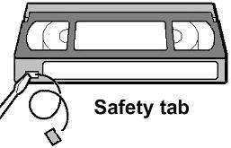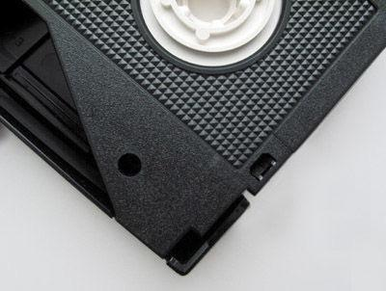

Store tapes vertically. When you shelve tapes, they should be fully rewound. And when you store them, make sure to knock out the “record-protect” tab. When this tab is removed, it prevents a VCR from recording on the tape—ensuring you won’t accidentally erase valuable video. Betamax VHS 

Should I play my tapes?

Yes! With caveats. Anyone who has videotapes has experienced the sadness of a tape being “eaten” by a VCR. With unique material like home videos, this damage can be tragic. But the video can’t be enjoyed if it can’t be seen. If you are playing back a home video, especially if your VCR is aged, or you’ve picked one up at a thrift store, you should test the deck with an unimportant tape—rewind it, fast forward it, and play it back—to make sure that your VCR isn’t a tape-eater.

Should I digitize my tapes?

Yes! With caveats. Digitizing analog videotape has many benefits. First, it lets you watch the video without risking damage to the tape during repeated playback. Second, it makes it far easier to share the video. Your intimate family moments can be seen by millions on YouTube!

There are many vendors that will digitize your videotape—mostly to DVDs. Home Video Day can’t recommend any specific vendors, but the costs are generally reasonable. One thing to keep in mind: if you do get DVDs, remember that they are no more an archival medium than videotape—they only have a shelf life of a few years. (Google “how do I back up my DVDs” for more information on this one.)

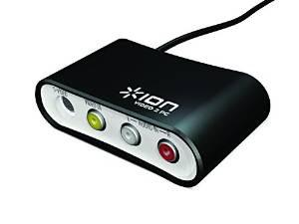

But you can also digitize them yourself! You will not be making professional, broadcast quality files. But VHS tapes aren't the highest quality to begin with, and you can get a perfectly good digital file with some basic equipment. In addition to a VCR and cables, you will need an Analog-Digital Converter. You can find them on [amazon.com](http://amazon.com) in the $50-$75 range. You want to make sure that it has “RCA” connections—the three white, yellow, and red connections that come out of the back of the VCR. (Of course, you also want to make sure it is compatible with your particular OS, and that it has the relevant connections—USB, for example—for your computer.) Basic software like Mac’s iMovie will let you “ingest” the video from the analog tapes. In addition to being cost-effective, the other advantage of DIY digitizing is that you will be able to edit the files yourself…before you share them, cut out the boring and/or embarrassing stuff!

The caveat: once you’ve created the digital files, you’ve got to take care of them, too. That’s an issue far beyond the scope of this document, but a great primer is at <http://digitalpreservation.gov/personalarchiving/>. Just keep in mind that the digitized video files will face the same software obsolescence and backwards-compatibility issues that you’ve experienced with other files.

If I digitize my tapes, should I throw then away afterward?

No! Videotape is indeed fragile—but archivists agree that original materials should always be kept, whenever it’s possible. First, digital files can be lost; retaining the tapes might give you the chance to re-digitize. Second, as digital video technology progresses, it may be possible to get a better-quality file from the same tape.

I taped over my wedding video! Can I get that video back?

This is the single most common question that videotape archivists and technicians get. The answer is: no. No technology can recover taped-over video. The lesson: knock out those record-protect tabs!

Where can I learn more?

Here are some helpful (we hope) links:

Transferring Video from Tape, DVD or Camera to Your Computer

<http://www.digitalpreservation.gov/personalarchiving/documents/video-transfer.pdf>

Great user-friendly summary of the issues, from the Library of Congress, no less.

Transfer VHS tapes to your computer

<http://www.cnet.com/how-to/transfer-vhs-tapes-to-your-computer/>

A slangy but decent summary of the issues, with helpful photos.

Digital Video Preservation and Oral History

<http://ohda.matrix.msu.edu/2012/06/digital-video-preservation-and-oral-history/>

A highly technical but nonetheless very clear and readable summary of analog-digital video preservation issues.