Identifying common film formats by sight

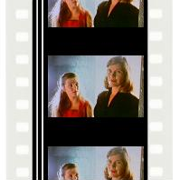
35mm
- 4 perforations per frame
- May be color/black and white; positive/negative; sound/silent
- Look for soundtrack stripe at left edge of picture area (optical—variable area or variable density) or on base side (magnetic—brown stripe)
- Most common format for commercial films

Note: 35mm film from the early 1950s and before may be nitrate! If “NITRATE” is printed along the edge, or there is a star by the manufacturer’s name it may be nitrate; if “SAFETY” or “S” followed by a number appears on the edge, it’s probably safety. The hash marks or dashes every fourth sprocket hole will be horizontal (same direction as the line between frames) on nitrate, vertical (perpendicular to the frame line) on safety. When in doubt, test or consult a pro!

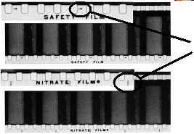

Nitrate and
safety films
with hash
marks

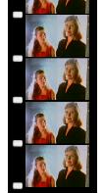
16mm
- 1 perforation per frame; 16mm is always safety!
- May be color/black and white; positive print, reversal positive original, or negative; sound/silent
- Look for soundtrack stripe opposite the perforations (optical—variable area or variable density) or on base side (magnetic)
- Most common format for educational films; also amateur and student films, from 1923 to the present

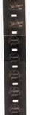
9.5mm
- 1 perforation between each frame, in center of film; 9.5mm is always safety!
- Introduced in France in 1922; still being produced in Europe
- May be color/black and white; positive print, reversal positive original, or negative; sound/silent
- Look for teardrop-shaped notches at intertitles; these are not damage, but part of patented mechanism to economize on film
- Used by amateur filmmakers and for home viewing of commercial films, especially overseas

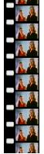
Regular 8mm
- 1 perforation per frame; perfs are same size as for 16mm film, oriented the same way as the image; 8mm is always safety!
- Introduced in 1932; produced until the 1990s
- May be color/black and white; usually reversal; usually silent
- Undeveloped 8mm film may be found on cartridges that look twice as wide as they need to be for such narrow film. A 25-foot roll of 16mm film was exposed down both sides, slit during processing, and spliced end-to-end to make a 50-foot roll of 8mm film.

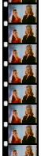
Super8
- 1 perforation per frame; smaller perfs than 8mm and 16mm, running perpendicular to the image; Super8 is always safety!
- Introduced in 1965; still being produced in several different formulations
- Usually color; usually reversal; may be sound/silent
- Look for soundtrack stripes on base side of film (magnetic)

