How to Host a Home Movie Day

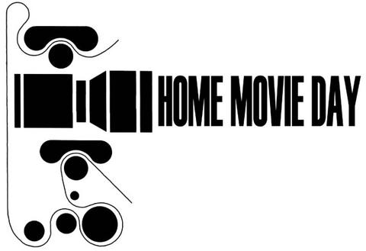

About Home Movie Day

Home Movie Day is an annual a celebration of amateur films and filmmaking held annually at many local venues worldwide.
Home Movie Day events provide the opportunity for individuals and families to see and share their own home movies with an audience of their community, and to see their neighbors' in turn. It's a chance to discover why to care about these films and to learn how best to care for them.
Home Movie Day events are held simultaneously around the world. The official date for 2012 is Saturday, October 20. Having events on the same day allows us to coordinate promotional activities.

Goals of Home Movie Day

- Preservation

In order for home movies to be used, considered, and enjoyed, they have to continue to exist, which means that we have to have ways of preserving them. Film is on one hand a surprisingly durable medium, but at the same time it can be extremely fragile. Prints from 1895 can still be in near pristine condition, while a poorly-maintained projector can destroy a brand new film just back from the lab.

The first step in the preservation process is convincing people not to throw their films away. It sounds obvious, but this still does happen with alarming frequency. Tell people that they should keep their original films even if they have been transferred to video (more on this later).

Home Movie Day is designed to create connections between archivists and audiences in order to provide preservation information for the films’ owners and also to cultivate possible donations to the archives. If your Home Movie Day isn’t associated with a specific archive, try to find an appropriate local or regional repository (such as a university or historical society) that might be interested in their films. Keep in mind, though, that not all archives are equipped to deal with film collections. The Center for Home Movies, Home Movie Day's host organization, is also available to help match potential donors with appropriate repositories for their collections or to consider donations themselves.

- Celebration

A second main point of Home Movie Day is to increase the understanding and appreciation of home movies. People are just starting to get over the stigma that home movies are boring or “all the same.” The easiest way to disabuse them of this idea is to get them to watch the films and see how much variety exists.

Hosting Home Movie Day

The Center for Home Movies acts as the umbrella organization and provides resources such as educational and promotional materials, as well as general help. We provide a few guidelines for the local events, but like to leave most of the event details up to the local organizers, figuring that you know your community best. In general, the three things all local events require are: a venue (preferably a donated one, since we strongly prefer that HMD events be free), equipment (including projectors and film inspection stations), and volunteers.

All official Home Movie Day events should include an open screening in which the public is encouraged to bring their home movies for inspection and projection. This is the core of Home Movie Day because it allows people to view their films—many of which haven’t been seen by them in many years, and shows the difference between film and video. Because it is crucial that the films not suffer any damage, films must be inspected before projection. Inspection can be performed either in advance by having people drop off their films at a designated location, or at the event itself.

Home Movie Day events should be prepared to project 8mm, super 8 and 16mm film, as these are the most common home movie formats. Other gauges may be provided when possible. The option of projecting video transfers of home movies is left to the local organizers.

In addition to the open screenings, organizers are encouraged to supplement their events with other activities, such as curated screenings from local archival collections.

For venues that would like to celebrate Home Movie Day, but aren’t equipped to run an open screening, HomeMovieDay.com also lists “Special Events,” such as film screenings, museum exhibitions, lectures, workshops, broadcasts and more.

Home Movie Day Communication

The primary means of communication about Home Movie Day (both from the Center for Home Movies and among the local organizers) is an invitation-only Google Group. We use this list for information exchange and discussion of all aspects of event planning with the HMD coordinators and other event hosts, everything from press talking points to finding 8mm leader. We require at least one person per city to be a member of the group, but anyone who is actively involved in event planning is encouraged to join.

When you are set up, visit the group page to access shared files and images, and browse the mail archives. Looking at messages from past Home Movie Days, including post-event reports from various hosts, is a good place to look for ideas in planning your own event. Once you're signed up, please introduce yourself to the list.
The "Home Movie Day 101" document prepared by Liz Coffey, the host of past HMD events is a great overview of how to prepare for your first Home Movie Day and what to expect from it.
Several months before Home Movie Day, we will start listing the local venues for the year on the Home Movie Day website. A call will be put out on the HMD Google Group for local site information. When you have details about your event it will be posted on the Home Movie Day website. If you like, you can start with a partial listing and update it as things take shape. Eventually we'd like to have the following on the site for each location:
City
Event Location
Host Organization (if applicable)
Organizer Name(s)
Organizer E-mail(s)
Contact phone
Event time
Additional info, such as website/MySpace/Facebook URL or directions
Contact Us

If you have any questions, feel free to contact the HMD coordinators at film@homemovieday.com or post them to the Google Group list, once you have subscribed.

