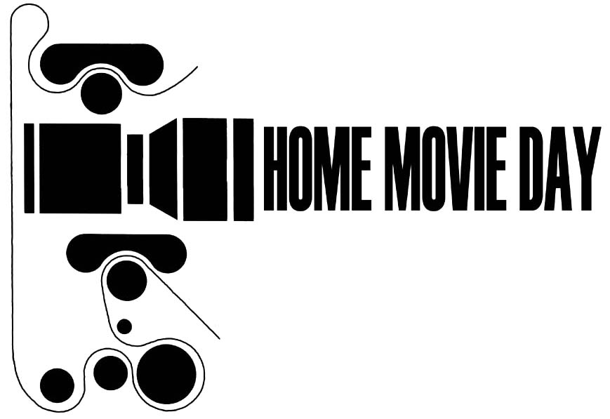

Participant Information Sheet

Thank you for taking part in Home Movie Day! We'd like to find out a little bit more about you. This information will be used for our reference and research purposes only—we won't send you junk mail or sell your personal information.

How did you find out about Home Movie Day? (Check all that apply)
- Local newspaper or television station
- Other newspaper or national TV
- Home Movie Day web site (www.homemovieday.com)
- Other Internet site or email list (please specify): ___________________
- A friend/relative told me about it
- Other (please describe): ______________________________________

- Yes, it is OK for an archivist to contact me about future Home Movie Day projects.
This information will not be distributed or used for any other purpose.

Name: ________________________________________
Address: ________________________________________
________________________________________
Phone: ________________________________________
E-mail: ________________________________________

- No, please do not contact me in the future.

