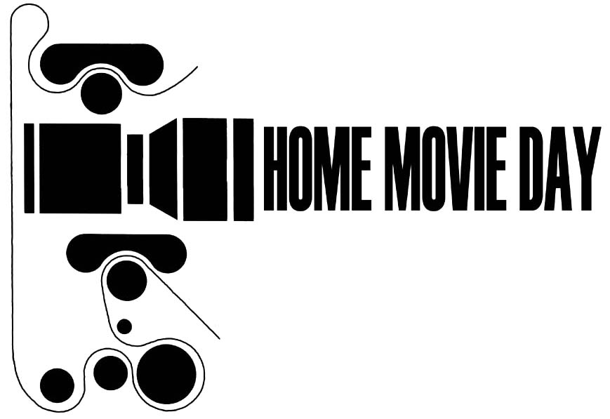

Participant Information Sheet

Thank you for taking part in Home Movie Day! We'd like to find out a little bit more about you. This information will be used for our reference and research purposes only—we won't send you junk mail or sell your personal information.

How did you find out about Home Movie Day? (Check all that apply)
- Local newspaper or television station
- Other newspaper or national TV
- Home Movie Day web site (www.homemovieday.com)
- Other Internet site or email list (please specify): ___________________
- A friend/relative told me about it
- Other (please describe): ______________________________________

Please briefly describe the films you brought with you today (how many reels/boxes, where they came from, who took them, what they depict—whatever you might know about them!).

We may be putting together another "Best of Home Movie Day" DVD compilation featuring outstanding films brought to Home Movie Day events around the world. Would it be OK for a film archivist to contact you about this project?

- Yes, it is OK for an archivist to contact me about my films and future Home Movie Day projects.
This information will not be distributed or used for any other purpose.

Name: ________________________________________
Address: ________________________________________
________________________________________
Phone: ________________________________________
E-mail: ________________________________________

- No, please do not contact me in the future.

Release Form for Projection and Viewing

I understand that time takes its toll on film. Old film may be brittle, shrunken, worn, or damaged in ways that are not immediately apparent. Age and poor physical condition may make film vulnerable to damage when projected or otherwise viewed. I understand that Home Movie Day organizers/volunteers/ archivists may not be held responsible for any damage that occurs to films brought by participants.

I also understand that Home Movie Day organizers/volunteers/archivists will carefully inspect my film(s) and provide their best estimate of current condition before any projection or viewing takes place. I understand the projectionist may choose not to project, or stop projection at any time, for any reason, at his or her sole discretion.

My signature below indicates that I have read and agree to the statements above. Now I want to see my home movies!

__________________________ _______
Participant signature date

__________________________
Name (please print)

__________________________
Home Movie Day Representative

