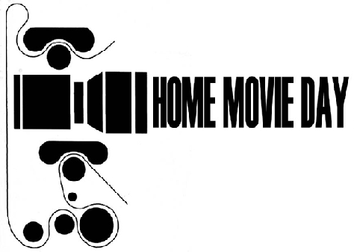
YOUR LOGO HERE
HOME MOVIE DAY 20XX – [YOUR CITY HERE]
Thank you for bringing us your film for [YOUR CITY HERE]’s 200? Home Movie Day. Below are some tips for so you can continue to care for your film

- Cool and dry is how best to store your film. Temperature and humidity in attics and basements are often extremes and often fluctuate frequently and shorten the life of your film.
- Do not store B&W and colour film on the same reel. Colour film should be stored in cooler temperatures than B&W to avoid colour fading.

- It is best to house your film in archival containers/cans which allow for proper air exchange. The cardboard boxes can be acidic and can hold onto moisture and metal cans are acceptable as long as long as they are not air-tight or rusted. Material made of plastic (polypropylene) is a good choice.

- Leader at both the head and tail of your film protects your film both for storage and projection. Never thread a film that is not leadered through in a projector.

- A film that smells of vinegar is starting to decay. Vinegar Syndrome cannot be reversed only slowed down.

- Films with magnetic soundtracks can often shed their magnetic stripe and suffer from Vinegar Syndrome more easily than silent film.

- Never use rubber bands, plastic clips or masking tape to hold down the ends of your film. Acid-free white artists paper tape is best.
- When winding film onto a reel, it is best not to use the slot in the reel for holding the film. Wrapping the film around the reel and itself a few times is often enough to hold the end in place to start winding.

- Transferring your film to video provides you with an ACCESS COPY for easier viewing, but is NOT considered PRESERVATION.

- Never attempt to unwind a film that has been through submerged in water or in a flood. Let a professional handle it.
- Always keep your original film even if you have it transferred to video!

- If you are considering donating your films to an archive, it is best to approach an archive whose mandate fits the subject matter of your films, and who knows how to deal with film. Do your research before donating!
Name:
Format(s) | Film provided for inspection for HMD is/was:
General Condition:
What was done to
your film:
Additional notes:
Film Content:
(if previously unknown)

