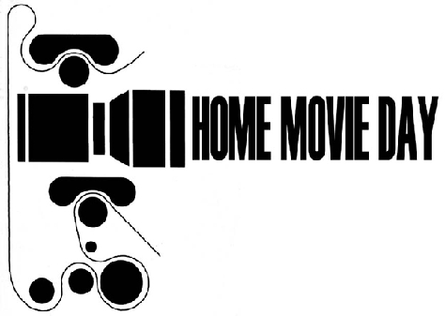
YOUR LOGO HERE
HOME MOVIE DAY 20XX – [YOUR CITY HERE]
Thank you for bringing us your film for [YOUR CITY HERE]’s 20?? Home Movie Day. Below are some tips for so you can continue to care for your film and video.

- Document the contents of your movies as best you can, with names, dates, addresses, etc.

- Cool and dry is the best way to store your film and video. Temperature and humidity in attics and basements are often extremes and often fluctuate frequently and shorten the life of your film.

- It is best to house your film and tape in archival containers/cans which allow for proper air exchange. Do not store them inside plastic bags, with rubber bands around them, or with paper. The cardboard boxes can be acidic and can hold onto moisture and metal cans are acceptable as long as long as they are not air-tight or rusted. Material made of plastic (polypropylene) is a good choice. Film should be stored flat, but don’t put too much weight on them. Videos should be stored vertically.

- Leader at both the head and tail of your film protects your film both for storage and projection. Never thread a film that is not leadered through in a projector.

- A film that smells of vinegar is starting to decay. Vinegar Syndrome cannot be reversed, only slowed down.

- Films with magnetic soundtracks can often shed their magnetic stripe and suffer from Vinegar Syndrome more easily than silent film.

- Never use rubber bands, plastic clips or masking tape to hold down the ends of your film. Acid-free white artists paper tape is best.
- When winding film onto a reel, it is best not to use the slot in the reel for holding the film. Wrapping the film around the reel and itself a few times is often enough to hold the end in place to start winding. Never attempt to unwind a film that has been through submerged in water or in a flood. Let a professional handle it.

Rewind tapes before you store them. Remove the “Record-Protect” tab to prevent accidentally erasing video.
- Transferring your film to video provides you with an ACCESS COPY for easier viewing, but is NOT considered PRESERVATION, so always keep your original film even if you have it transferred to video.

- If you are considering donating your films to an archive, it is best to approach an archive whose mandate fits the subject matter of your films, and who knows how to deal with film. Do your research before donating!
Name:
Format(s) | Films/Tapes provided for inspection for HMD are/were:
General Condition:
What was done to
your films/tapes:
Additional notes:
Film Content:
(if previously unknown)

