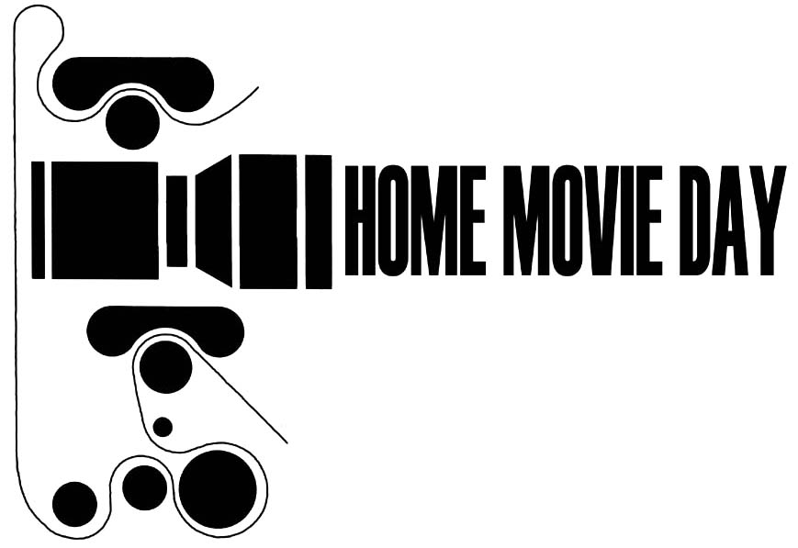
Home Movie Day
Advance Film Drop-Off Form

Thank you for taking part in Home Movie Day! We’re excited to have your film to show at our event. Please provide ALL the following information (for your safety and ours, films will not be accepted for Home Movie Day screening without completed forms).

Date:____________________ Accepted by:___________________________________

Your Name:______________________________________________________________
Home Address:___________________________________________________________
Mailing Address (if different):________________________________________________
Daytime phone:_______________________ Evening phone:______________________
Alternate phone:_______________________
Email:_______________________________

Please briefly describe the films you brought with you today (how many reels/boxes, where they came from, who took them, what they depict—whatever you might know about them).
_____________________________________________________________________________________________________________________________________________________________________________________________________________________
Number of items dropped off:__________________________________________
Format (if known): 8mm__ Super8__ 16mm__ Mixed formats__ Unknown__
Other_____________________________________________________________
------------------------------------------receipt-------------------------------------------------
# of films received:

Your event’s information here…

You may pick up your films at the event immediately after screening. Any films unclaimed after xxx will be held at XXXX for pickup. Please call [name] at (###) ###-#### with any inquiries.

Release Form for Projection and Viewing

I understand that time takes its toll on film. Old film may be brittle, shrunken, worn, or damaged in ways that are not immediately apparent. Age and poor physical condition may make film vulnerable to damage when projected or otherwise viewed. I understand that Home Movie Day organizers/volunteers/ archivists may not be held responsible for any damage that occurs to films brought by participants.

I also understand that Home Movie Day organizers/volunteers/archivists will carefully inspect my film(s) and provide their best estimate of current condition before any projection or viewing takes place. I understand the projectionist may choose not to project, or stop projection at any time, for any reason, at his or her sole discretion.

My signature below indicates that I have read and agree to the statements above. Now I want to see my home movies!

________________________________________ ________________
Participant signature date

_________________________________________
Name (please print)

